

**PRODUCT SPECIFICATION SHEET**

**“POD” PAPER ROLL DISPENSER WITH RESERVE FEATURES**

# KHP PART No. CAB POD MK2 RSV

### **DESCRIPTION**

* Transparent ABS cover for easy paper roll level indication.
* Automatic paper follow-on feature for presenting paper in advance of the next operation.
* Designed to be used with a 20cm diameter paper roll with a maximum roll width of up to 21cm.
* Automatic reserve feature – Once the roll reaches 9.5cm in can be put into the reserve position and a new roll loaded, the new roll automatically loads itself ones the first roll has depleted.
* Cut sheet length 28cm.
* Tough, long lasting steel shaft driven mechanism.
* Self-supporting lid.
* Minimum maintenance required.
* Left/Right hand lock. Locks uses key common with other products in the range.
* Anti-vandalism clutch feature on the handle which protects the mechanism from any damage through excess force.

### **DIMENSIONS**

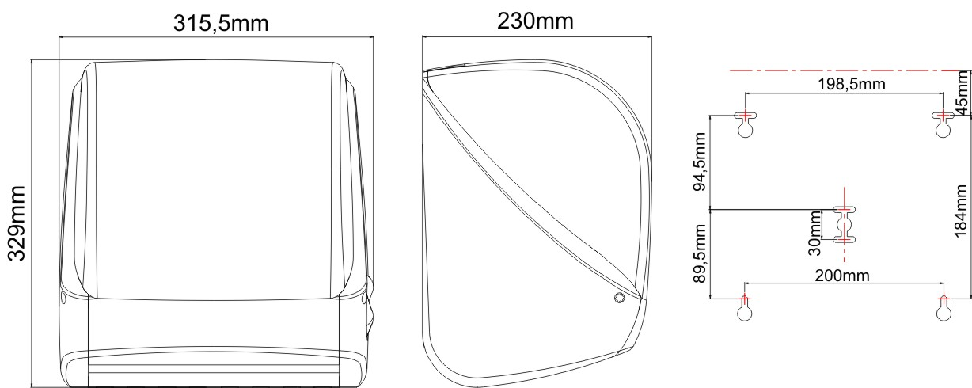

### **MATERIALS**

Constructed from ABS, other engineering thermoplastics and metal fabrication where necessary for strength and reliability.

Cabinet can be recycled or disposed of in accordance with local regulations.

### **PACKAGING**

2 Cabinets are packed into a double wall box with key and instruction sheet.

Box dimensions: 47cm x 32cm x 33cm

****Individual Weight: 2.3Kg

Total weight: 5.2kg